### **Time And Work:-**

### A &B working separately can do a piece of work in 9 & 12 days respectively. If they work for a day alternatively, A beginning, in how many days, the work will be completed? Ans:-72/7

### A can do a work in 12 days. When he had worked for 3 days B joined him. If they complete the work in 3 more days. In how many days can B alone can finish the work? Ans:-6 or 3days(check it)

Two workers A and B are engaged to do a work. A working alone takes 8 hours more to complete the job than if both worked together. If B worked alone, he would need   
4.5 hours more to complete the job than they both working together. What time would they take to do the work together ?

Ans:-

A working alone takes 8 hours more to complete the job than if both worked together.  
=> a(x+8) = (a+b)x   
=> ax + 8a = ax + bx   
=> 8a = bx or a = bx/8 ---(1)  
If B worked alone, he would need 4.5 hours more to complete the job than they both working together  
  
=> b(x+4.5) = (a+b)x  
=> bx +4.5b = ax + bx  
=> 4.5b = ax or a = 4.5b/x ---(2)  
  
From (1) and (2), we have  
bx8=4.5bx⇒x2=4.5∗8⇒x=6

### X is 3 times as fast as Y and is able to complete the work in 40 days less than Y. Find the time in which they can complete the work together?Ans-15days

# A can complete a work in 16 days and B in 12 days. Starting with A, they work on alternate days. The total work will be completed in how many days?Ans- 13 and 3/4 days or 14 days.

# Amit, Bhawna and Chandan can do a piece of work, working together in one day only. Amit is 5 times efficient than Bhawna and Chandan takes half of the number of days taken by Bhawna to do the same work. What is the difference between the number of days taken by Amit and Chandan when they work alone?Ans:-2.4days

Efficiency Must be like this:

Amit Bhavna Chandan

1days 5days 2.5days

2 10 5

**Time and Distance:-**

A man covered a certain distance at some speed. Had he moved 3 km/ph faster, he would have taken 40 minutes less. If he had moved 2 km/ph slower, he would have taken 40 minutes more. The distance (in km) is:

|  |  |  |  |  |  |
| --- | --- | --- | --- | --- | --- |
| *x* | - | *x* | = | 40 | https://www.indiabix.com/_files/images/aptitude/1-sym-imp.gif   2*y*(*y* + 3) = 9*x* ....(i) |
| *y* | *y* + 3 | 60 |

|  |  |  |  |  |  |  |
| --- | --- | --- | --- | --- | --- | --- |
| And, | *x* | - | *x* | = | 40 | https://www.indiabix.com/_files/images/aptitude/1-sym-imp.gif   *y*(*y* - 2) = 3*x* ....(ii) |
| *y* -2 | *y* | 60 |

Excluding stoppages, the speed of a bus is 54 km/hr and including stoppages, it is 45 km/hr. For how many minutes does the bus stop per hour?

Due to stoppages, it covers 9km less per hour.  
Time is taken to cover 9 km = (9/54×60)min  
= 10 min  
So, the bus stops for 10 min. per hr.

John travelled from his town to city. John went to city by bicycle at the speed of 25 km/h and came back at the speed of 4 km/h. If John took 5 hours and 48 min to complete his journey, what is the distance between town and city ?

Average speed of John = 2xy/x+y = 2 × 25 × 4 / 25 + 4= 200/29 km/h  
⇒ Distance traveled = Speed × Time = 200/29 × 29/5 = 40 Km  
⇒ Distance between city and town = 40/2 = 20 km

In a kilometer race, A beats B by 100 meters. B beats C by 100 meters. By how much meters does A beat C in the same race ?

**Logarithm:-**

The value of log2 16 is:

log2 16 = *n.*

Then, 2*n* = 16 = 24     https://www.indiabix.com/_files/images/aptitude/1-sym-imp.gif     *n* = 4.

https://www.indiabix.com/_files/images/aptitude/1-sym-tfr.gif log2 16 = 4.

log 2 *x* = 10     https://www.indiabix.com/_files/images/aptitude/1-sym-imp.gif     *x* = 210

log*x* *y* = 100 https://www.indiabix.com/_files/images/aptitude/1-sym-imp.gif  *y* = *x*100

|  |  |  |  |  |  |  |  |  |  |  |  |  |  |  |  |  |  |  |  |  |  |  |  |  |  |  |  |  |  |  |  |  |  |  |  |  |  |  |  |  |  |  |  |  |  |  |  |  |  |  |  |  |  |  |
| --- | --- | --- | --- | --- | --- | --- | --- | --- | --- | --- | --- | --- | --- | --- | --- | --- | --- | --- | --- | --- | --- | --- | --- | --- | --- | --- | --- | --- | --- | --- | --- | --- | --- | --- | --- | --- | --- | --- | --- | --- | --- | --- | --- | --- | --- | --- | --- | --- | --- | --- | --- | --- | --- | --- |
| |  |  |  |  |  |  |  |  |  |  |  |  |  |  |  |  |  |  |  |  |  |  |  |  |  |  |  |  | | --- | --- | --- | --- | --- | --- | --- | --- | --- | --- | --- | --- | --- | --- | --- | --- | --- | --- | --- | --- | --- | --- | --- | --- | --- | --- | --- | --- | | log10 |  |  |  |  |  |  |  |  |  |  |  |  |  |  |  |  |  |  |  |  |  |  |  |  | https://www.indiabix.com/_files/images/aptitude/1-sym-oparen-h1.gif | 1 | https://www.indiabix.com/_files/images/aptitude/1-sym-cparen-h1.gif | |  |  |  |  |  |  |  |  |  |  |  |  |  |  |  |  |  |  |  |  |  |  |  |  | 70 | | = log10 1 - log10 70 |
|  | = - log10 (7 x 10) |

|  |  |
| --- | --- |
| log10 80 | = log10 (8 x 10) |
|  | = log10 8 + log10 10 |
|  | = log10 (23 ) + 1 |

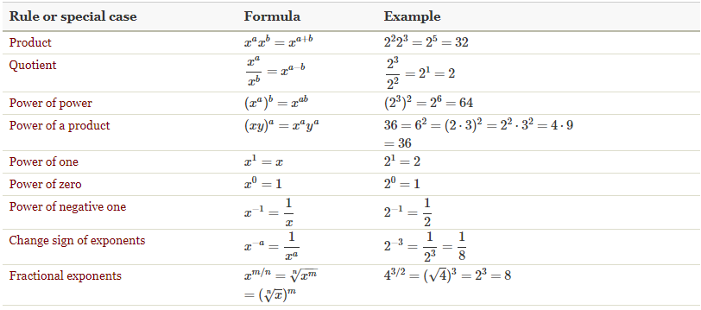

**Election Problem**

Two candidates contested an election. 10% of people on the voting list did not vote and 60 votes recorded were rejected as illegal. The majority of successful candidate was 380 and it was found that he had been supported by 47% of the whole number of the voter's list. What were the legal votes recorded each candidates.

Ans:- Winner got 47% votes  
Loser got (47%-380) votes  
10% did not vote  
60 votes were rejected as illegal  
  
Therefore, 47% + (47% - 380) + 10% + 60 = 100%  
=> 104% - 320 = 100%  
=> 4% = 320  
=> 1% = 80  
=> 47% = 47×80=3760 (votes of the winner)  
  
3760 - 380 = 3380 (votes of the loser).

In an election between two candidates, one got 55% of the total valid votes, 20% of the votes were invalid. If the total number of votes was 7500, the number of valid votes that the other candidate got, was:

Ans:- Number of valid votes = 80% of 7500 = 6000.

https://www.indiabix.com/_files/images/aptitude/1-sym-tfr.gif Valid votes polled by other candidate = 45% of 6000

|  |  |  |  |  |  |
| --- | --- | --- | --- | --- | --- |
| = | https://www.indiabix.com/_files/images/aptitude/1-sym-oparen-h1.gif | 45 | x 6000 | https://www.indiabix.com/_files/images/aptitude/1-sym-cparen-h1.gif | = 2700. |
| 100 |

**Mixture And Allegation**

8 litres are drawn from a cask full of wine and is then filled with water. This operation is performed three more times. The ratio of the quantity of wine now left in cask to that of the water is 16 : 65. How much wine the cask hold originally?

Ans:- Let the quantity of the wine in the cask originally be x litres

Then, quantity of wine left in cask after 4 operations =[x(1−8x)4]x1-8x4litres

∴[x(1−8x)4x] = 1681∴x1-8x4x = 1681

 ⇒[1−8x]4=(23)4⇒1-8x4=234

⇒x=24⇒x=24

# A container contains 40 litres of milk. From this container, 4 litres of milk were taken out and replaced by water. This process was repeated further two times. How much milk is now contained by the container?

Ans:-

x(1−yx)n(1−yx)n

Milk contained by Container now

= 40(1−440)340(1−440)3

= 40(1−110)340(1−110)3

= 40∗910∗910∗91040∗910∗910∗910

= 4∗9∗9∗91004∗9∗9∗9100

= 29.16

# Out of his total income, Mr. Kapur spends 20% on house rent and 70% of the rest on household expenses. If he saves Rs.1,800 what is his total income (in rupees) ?

Ans:-   
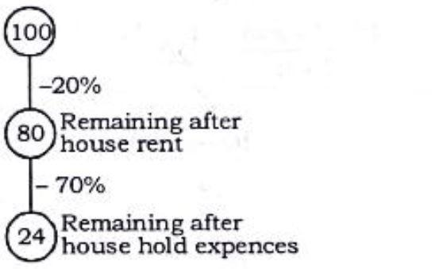

24 units = Rs. 1800  
  
1 unit = Rs.180024180024  
  
100 units = Rs.180024×100180024×100  
  
= Rs. 7500